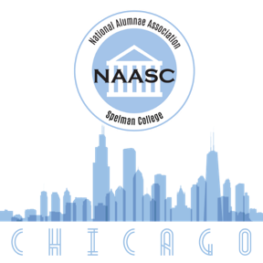
Lois Davenport Fambro Scholarship Application
Awarded by the Chicago Chapter of the NAASC

Please complete the following scholarship application by August 31st (for Fall award) and/or January 31st (for Spring award). Send the completed scholarship form to Barbara Edwards, C’69, Scholarship Chairperson, at NAASCchicago@gmail.com

Full Name:
Email:
Spelman Email:
Phone Number:
Spelman Student ID:

Parent/Guardian Name:
School Address:
Permanent Home Address:

Expected Graduation Year:
GPA:
Major and/or Minor:

Scholarship Application Period (Fall/Spring and year):
Requested Award Amount:

List of Extracurricular Activities:

Please write a brief explanation of why you are requesting financial assistance.

If you do not receive this scholarship award, how will you fund your education?

